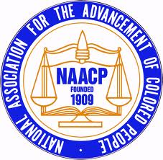
FOR IMMEDIATE RELEASE
January 15, 2016, 8:00 AM
Contact: Xavier Mason, (907) 310-0319

NAACP Youth Council Commits to Community Involvement
Day of Service in celebration of Dr. Martin Luther King, Jr.

ANCHORAGE: The Anchorage NAACP Youth Council in partnership with the Alaska Sierra Club, the Mountain View Lions Club and a number of other organizations are committing a day of service on January 18th in celebration of the Dr. Martin Luther King, Jr., Holiday.

The event will begin at the Mt. View Lions Club, 501 N. Pine at 10:00 a.m. to 12:30 p.m. The plan is to present two events, the first being a Day of Service for the Mt. View Committee through providing snow shoveling and picking up trash around the neighborhood. And the second event is a “Taste of Mt. View” beginning at 1:00 p.m., and ending at 3:00 p.m. at the Mt. View Boys and Girls Club.
The main purpose for this event is to create an open dialogue in Anchorage’s most diverse neighborhood, provide a service opportunity for role model individuals and organizations in Anchorage and support economic development by highlighting local businesses.

###

